*A Project Report*

*on*

**IoT based Smart Assistance (Spoon) for Parkinson Patients**

*carried out as part of the course (Course code) Submitted by*

***Vivek Raj***

***169105217***

***Wasim Ekram***

***169105218***

***6th Semester BTech CSE-D***

*in partial fulfillment for the award of the degree*

*of*

**BACHELOR OF TECHNOLOGY**

In

**Computer Science & Engineering**

**Department of Computer Science & Engineering,**

**School of Computing and IT,**

**Manipal University Jaipur,**

***January - April, 2019***

**CERTIFICATE**

This is to certify that the project entitled "( IoT based Smart Assistance (Spoon) for Parkinson Patients. )" is a bonafide work carried out as part of the course (Minor Project Lab ), under my guidance by (Wasim Ekram), student of (Btech CSE 6th semester) at the Department of Computer Science & Engineering , Manipal University Jaipur, during the academic semester (semester), in partial fulfillment of the requirements for the award of the degree of Bachelor of Technology in Computer Science & Engineering, at MUJ, Jaipur.

Place: Manipal University Jaipur

Date: 26th April 2019 Signature of the Instructor (s)

**CERTIFICATE**

This is to certify that the project entitled "( IoT based Smart Assistance (Spoon) for Parkinson Patients. )" is a bonafide work carried out as part of the course (Minor Project Lab ), under my guidance by (Vivek Raj), student of (Btech CSE 6th semester) at the Department of Computer Science & Engineering , Manipal University Jaipur, during the academic semester (semester), in partial fulfillment of the requirements for the award of the degree of Bachelor of Technology in Computer Science & Engineering, at MUJ, Jaipur.

Place: Manipal University Jaipur

Date: 26th April 2019 Signature of the Instructor (s)

**DECLARATION**

I “WASIM EKRAM” student of Bachelor of Technology in Computer Science and Engineering, MANIPAL UNIVERSITY JAIPUR, JAIPUR hereby declare that the work presented in the dissertation entitled **“IoT based Smart Assistance (Spoon) for Parkinson Patients.”** is outcome of my own work carried out during VI Semester 06-01-2019 to 26-04-2019 under the supervision of Ms. Anubha Parashar, is bonafide and correct to the best of my knowledge and this work has been carried out taking care of engineering ethics. The work presented does not infringe any patent work and has not been submitted to any pother university or anywhere else for the award of any degree, associate ship, fellowship or any other similar titles elsewhere.

Further, I declare that I will not share, re-submit or publish the code, idea, framework and/or any publication that may arise out of this work for academic or profit purposes without obtaining the prior written consent of the Course Faculty Mentor and Course Instructor.

Wasim Ekram

169105218

Signature of the Student

**DECLARATION**

I “VIVEK RAJ” student of Bachelor of Technology in Computer Science and Engineering, MANIPAL UNIVERSITY JAIPUR, JAIPUR hereby declare that the work presented in the dissertation entitled **“IoT based Smart Assistance (Spoon) for Parkinson Patients.”** is outcome of my own work carried out during VI Semester 06-01-2019 to 26-04-2019 under the supervision of Ms. Anubha Parashar, is bonafide and correct to the best of my knowledge and this work has been carried out taking care of engineering ethics. The work presented does not infringe any patent work and has not been submitted to any pother university or anywhere else for the award of any degree, associate ship, fellowship or any other similar titles elsewhere.

Further, I declare that I will not share, re-submit or publish the code, idea, framework and/or any publication that may arise out of this work for academic or profit purposes without obtaining the prior written consent of the Course Faculty Mentor and Course Instructor.

Vivek Raj

169105217

Signature of the Student

**ACKNOWLEDGEMENT**

I take this opportunity to thank all those magnanimous persons who rendered their full services to my work.

It’s with lot of happiness we are expressing gratitude to our guide **Ms. Anubha Parashar** B.Tech, Assistant professor, Computer Science and Engineering, for her timely and kind help, guidance and for providing us with most essential materials required for the completion of the completion of this project. We are very thankful to him for his indomitable guidance. This inspiration up to the last moment had made things possible in a nice manner.

I thank Mr. **Prashant Manuja**, Computer Science and Engineering Department for their cooperation extended for the successful completion of the project.

Finally, I thank each and every one who helped to complete my project work with their cordial support.

**LIST OF CONTENTS**

**Sr. No Title**

**1. CERTIFICATE**

**2. DECLARATION**

**3. ACKNOWLEDGEMENT**

**4. ABSTRACT**

**5. INTRODUCTION**

5.1 Purpose

5.2 Scope of the Work

5.3 Motivation

**6. Literature Review**

6.1 Problem Statement

6.2 Literature Review

6.3 Proposed Work plan of the project (Timeline)

**7.System Specification**

7.1 System Requirements

7.1.1 Functional requirements

7.1.2 Non-Functional Requirements

7.1.3 Software Requirements

7.1.4 Hardware Requirements

**8. Methodology and Framework**

8.1 Proposed System

8.2 Methodology

8.3 Detail Description of algorithm designed

**9. Result and Discussion**

9.1 Result

**10. Conclusion and Future Scope**

10.1 Conclusion

10.2 Future Scope of the Project

**4. ABSTRACT**

* The arm control by robotics is very popular in the world of robotics. The essential part of the robotic arm is a programmable micro controller-based brick capable of driving basically four servos to form an anthropomorphic structure.
* Our primary objective is to make the Robotic arm, having 4 servo motors to interface with the development of a microcontroller based Robotic arm. It provides more interfaces to the outside world and has larger memory to store many programs.

**5. INTRODUCTION**

**5.1 Purpose**

* The technology for assisting people who are functionally challenged has improved over the recent decades.
* A group that suffer from this ailment are people with Parkinson’s disease.
* Parkinson’s disease (PD) is a neurological degenerative disease that causes uncontrollable shaking and makes it difficult for the affected person to eat.
* There is no cure for PD, but there is technology and potential for new technology that can help people who carry the disease with their daily lives.

**5.2 Scope of the Project**

* The machine will be of great use to perform repetitive tasks of picking and placing of small edibles upto 500 grams in one serving.
* It can be used to do small assembly work effectively due to its great added accuracy for placement purpose, which has further extended scope of our project.

**5.3 Motivation**

* The motivation of this project is to investigate how an Arduino microcontroller and servo motors can be implemented to help people with impaired motor skills.

**6. Literature Review**

**6.1 Problem Statement**

* The aim of the project is to make the machine more efficient whit high stability so that the food doesn’t spill.
* It is necessary for it be easily usable as it will operated by patients or nurses.
* We need to make a machine that can feed the said patient with no efforts needed that will pick the food and spoon feed it to the patient. With a low budget, the goal is to make a highly efficient prototype that consists mainly of a microcontroller and servo motors.
* We need to learn all about Arduino or Raspberry Pi in order proceed with this project

**6.2 Literature Review**

* The chapter presents a background on the importance of robotics in real life, assistance in daily workload, the importance of creativity and entrepreneurship in business, and the different technologies used in designing a mechanical arm.

**6.3 Proposed Work plan of the project (Timeline)**

Proposed Duration for the Project: 5 Months.

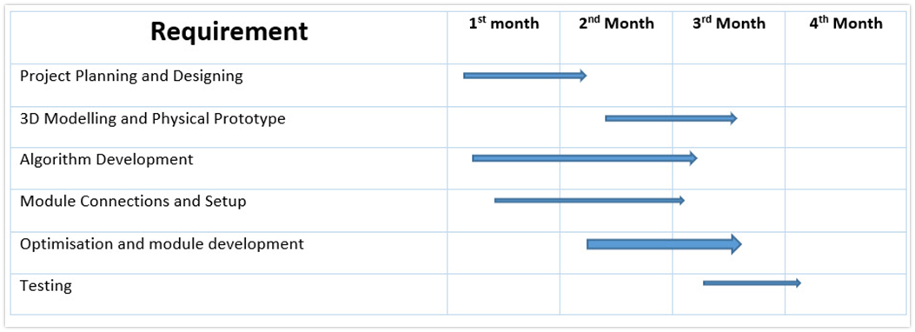

**7. System Specification**

**7.1 System Requirements**

**7.1.1 Functional requirements**

* The robotic arm should be highly reliable.
* The robotic arm should have great stability while handling food items
* The robot should have negligible failure rate

**7.1.2 Non-Functional Requirements**

* Security for the control of the app making it password protected.
* Validate robot’s version information through the app.

**7.1.3 Software Requirements**

* Arduino Software (IDE) - Arduino IDE is an open-source software program that allows users to write and upload code within a real-time work environment. As this code will thereafter be stored within the cloud, it is often utilized by those who have been searching for an extra level of redundancy. The system is fully compatible with any Arduino software board.
* Photoshop for designing app elements
* PyCharm
* MIT App Inventor for creating the Bluetooth app

**7.1.4 Hardware Requirements**

* Robotic Arm Frame
* Arduino
* Servo Motors
* Wi-Fi Module
* Bluetooth Module
* Jumper Cables
* Breadboard
* Robotic Arm Frame

**8. Methodology and Framework**

**8.1 Proposed System**

Following is our plan of actions:

* Procurement of necessary parts for assembling the setup.
* Create a blueprint and do the necessary project planning.
* Placing the display behind the acrylic mirror which is to be enclosed around a wooden frame.
* Programming on Raspberry Pi and controlling multiple servo motors.
* Designing Robotic arm and getting it printed from the 3D printing Lab.
* Setting up the model along with the servo motors.
* Linking other hardware components.
* Setting up the camera module.
* Applying Image Detection and making the arm work accordingly.
* Testing the entire setup.

**8.2 Methodology**

* Deciding on all the small tasks the machine should be able to perform.
* To avoid change in the number of components or the type of components, the working of the robot was divided into a group of smaller functions.
* The number, sizes, and type of components were carefully decided upon, so that minimum changes happen in requirements, while building the model
* Obtaining all the hardware required for the project.
* Some of the components that were needed for our project were obtained from the IOT lab of our college.
* The rest of the components that were unavailable were bought from online stores and hardware shops
* Building the working model with all the motors attached.
* A simple model was initially made to test the strength and the functions of a servo motor.
* Then a model of a robotic arm was selected, and the necessary changes were decided upon, that will be designed.

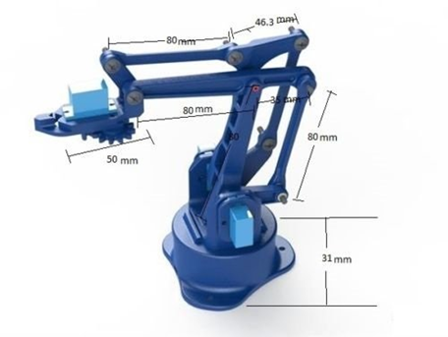

* The pre- selected 3D model was bought from an online store, and the robotic arm was assembled.

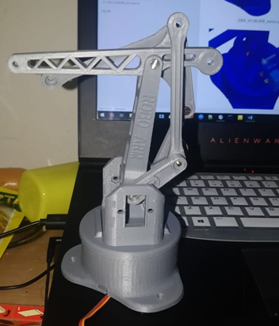

* The required number of servo motors were attached to the model, so that the robot can perform every kind of movement.

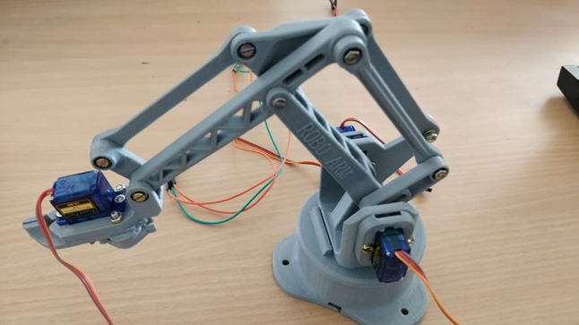

* Coding the different small tasks on different motors one by one.
* The way of connecting an Arduino to a phone was established so that the model can be controlled wirelessly.

**8.3 Detail Description of algorithm designed**

**Process Diagram of Bluetooth app**

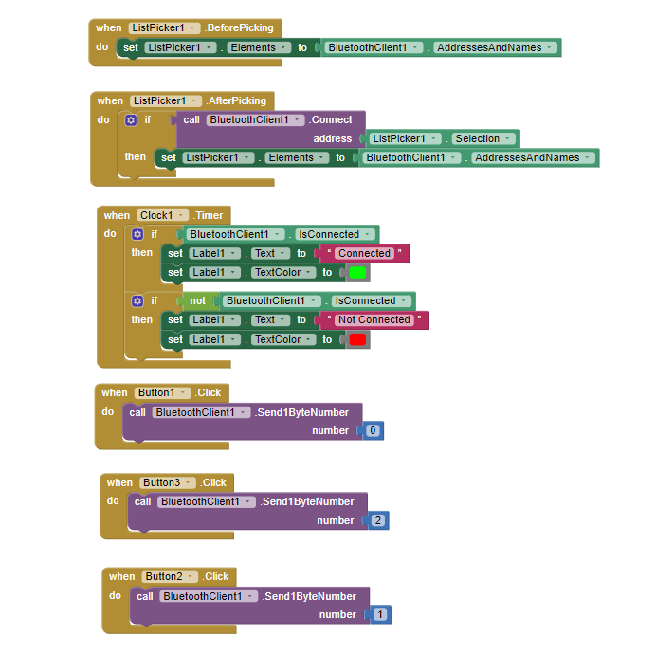

**Code**

#include <VarSpeedServo.h>

#include<SoftwareSerial.h>

VarSpeedServo servo1;

VarSpeedServo servo2;

VarSpeedServo servo3;

VarSpeedServo servo4;

const int servo1Pin = 3;

const int servo2Pin = 5;

const int servo3Pin = 6;

const int servo4Pin = 9;

int bluetoothTx = 10;

int bluetoothRx = 11;

SoftwareSerial bluetooth(bluetoothTx, bluetoothRx);

void setup() {

servo1.attach(servo1Pin);

servo2.attach(servo2Pin);

servo3.attach(servo3Pin);

servo4.attach(servo4Pin);

Serial.begin(9600);

bluetooth.begin(9600);

delay(2000);

}

void loop() {

if(bluetooth.available()>0)

{

int command = bluetooth.read();

Serial.println(command);

if(command == 0)

{

servo1.write(25, 10, true);

delay(500);

servo2.write(110, 10, true);

delay(500);

servo3.write(35, 10, true);

delay(500);

servo4.write(100, 10, true);

delay(1000);

servo4.write(75, 10, true);

delay(500);

servo1.write(120, 10, true);

delay(20);

servo3.write(125, 10, true);

delay(20);

servo2.write(120, 10, true);

delay(1000);

}

else if(command == 1)

{

servo1.write(90, 20, true);

servo2.write(90, 20, true);

servo3.write(90, 20, true);

servo4.write(90, 20, true);

delay(5000);

}

else if (command == 2)

{

servo1.write(25, 10, true);

delay(500);

servo2.write(75, 10, true);

delay(500);

servo3.write(50, 10, true);

delay(500);

servo4.write(115, 10, true);

delay(1000);

servo2.write(105, 10, true);

delay(500);

servo3.write(45, 10, true);

delay(500);

servo4.write(75, 10, true);

delay(500);

servo1.write(120, 10, true);

delay(20);

servo3.write(125, 10, true);

delay(20);

servo2.write(120, 10, true);

delay(1000);

}

} }

**9. Result and Discussion**

**9.1 Result**

* The robotic arm model was successfully implemented which was able to pick up food from the tray and direct it towards the mouth of the user.
* The Bluetooth app for connecting to the arm, controlling and terminating the process was also developed.

**9.2 App Screenshots**

The app was designed using MIT App Inventor that could connect to the Arduino. The app is used to connect an Android phone to the Arduino so that one could easily operate the robot as desired. The app is easily customizable and highly reliable.

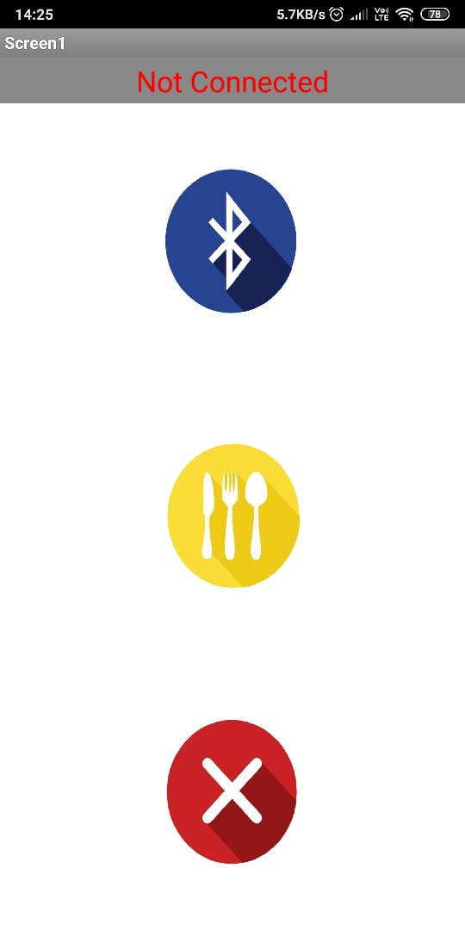

**10. Conclusion and Future Scope**

**10.1 Conclusion**

* The objectives of this project have been achieved which was developing the hardware and software for a user controlled robotic arm.
* From observation that has been made, it clearly shows that its movement is precise, accurate, and is easy to control and user friendly to use.
* The robotic arm has been developed successfully as the movement of the robot can be controlled precisely.
* This robotic arm control method is expected to overcome the problem such as placing or picking edibles towards the user in a very fast and easy manner.

**10.2 Future Scope**

The further work to be done is:

* Making it commercially viable and cheap enough.
* Designing an exterior shell for the robotic arm.
* Making it more compact and easier to store
* Making it chargeable.